Case 12-US-GA-Mississippian-Ceremonial axe or spud-900 CE

SHAPE \* MERGEFORMAT 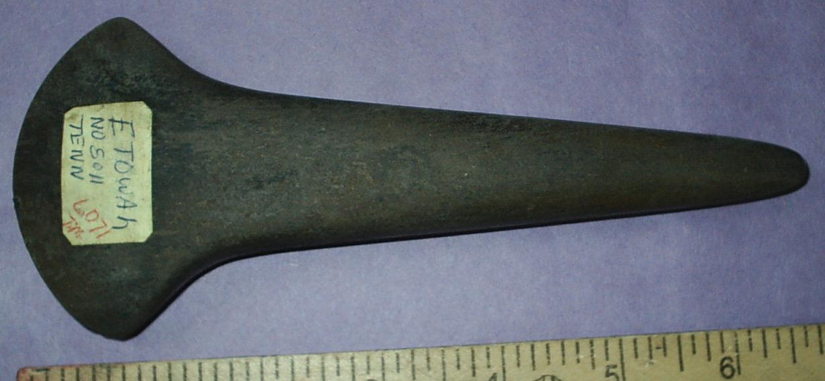 SHAPE \* MERGEFORMAT 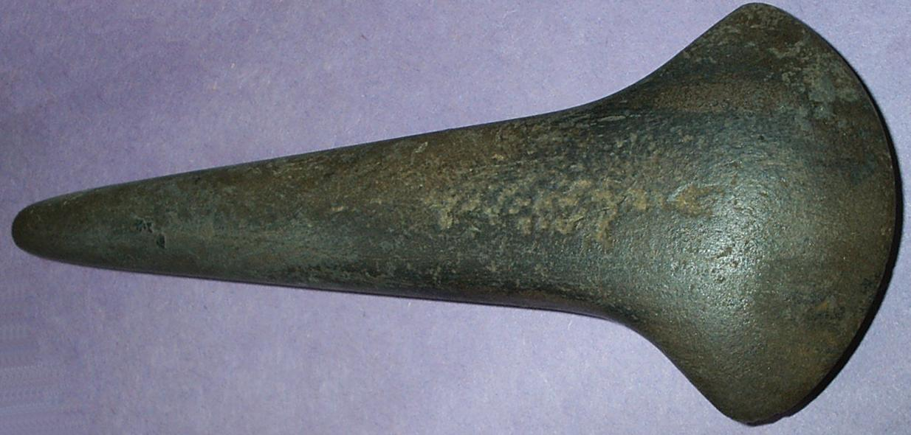

Ceremonial axe or spud from Etowah site, No 5011 (LO71) Georgia
INCLUDEPICTURE "D:\\..\\..\\Local Settings\\Temp\\scl12.jpg" \* MERGEFORMAT 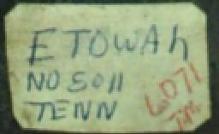
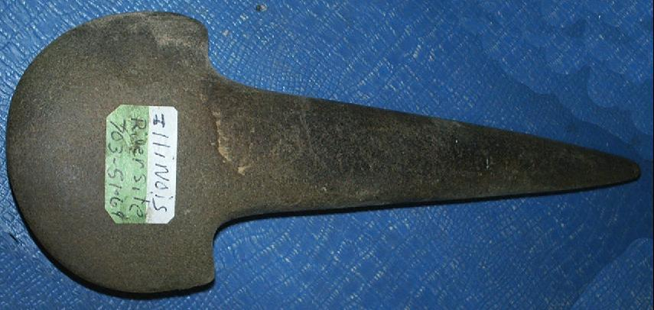 SHAPE \* MERGEFORMAT 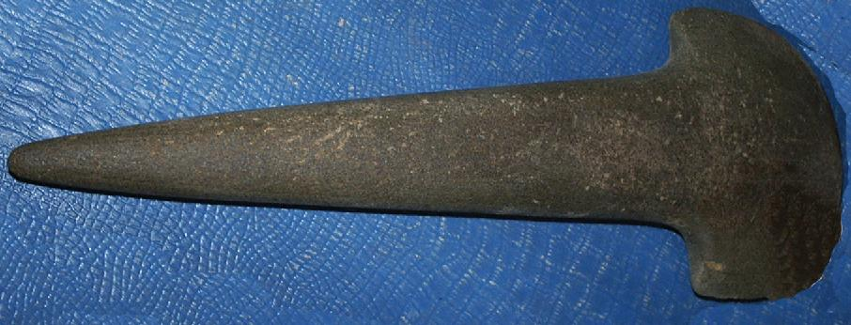
Ceremonial axe or spud from Illinois River Site, 701-S3-69
SHAPE \* MERGEFORMAT 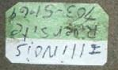
SHAPE \* MERGEFORMAT 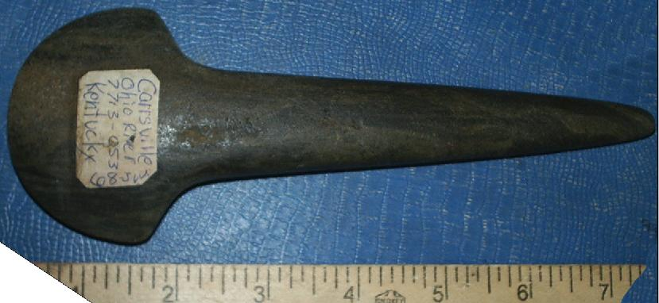 SHAPE \* MERGEFORMAT 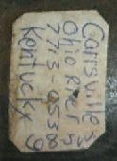

Carrsville, Kentucky, Ohio River 7713-053, C08 J-uu.
SHAPE \* MERGEFORMAT 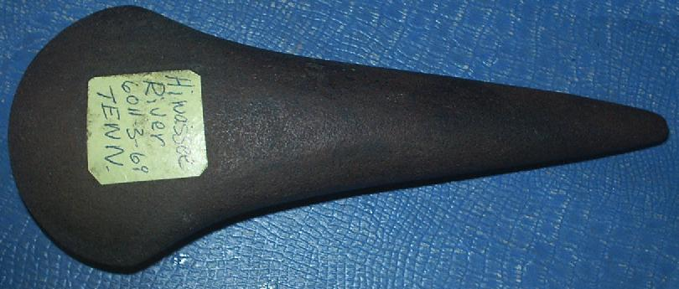 SHAPE \* MERGEFORMAT 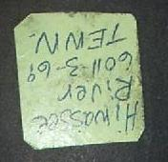
Hiwasee River, Tennessee, 6011-3-69

